STEP1: 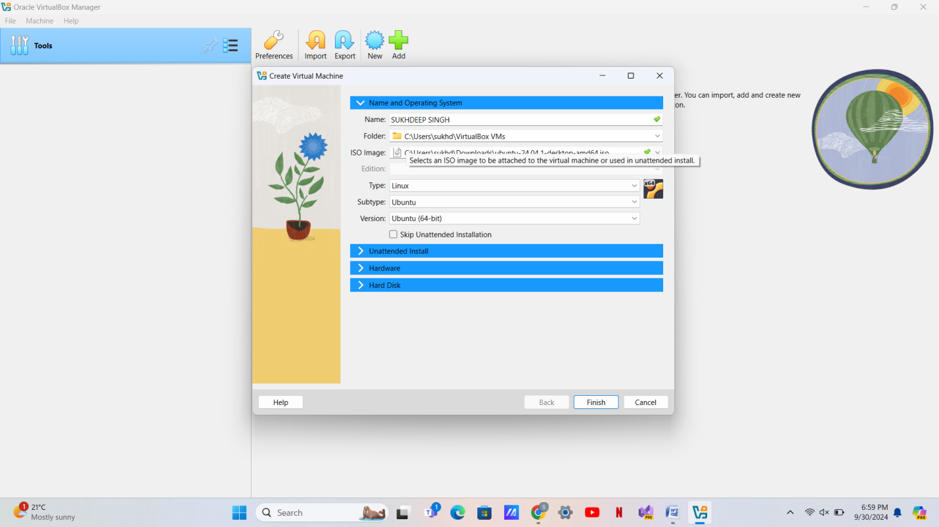

STEP 2

S

STEP2 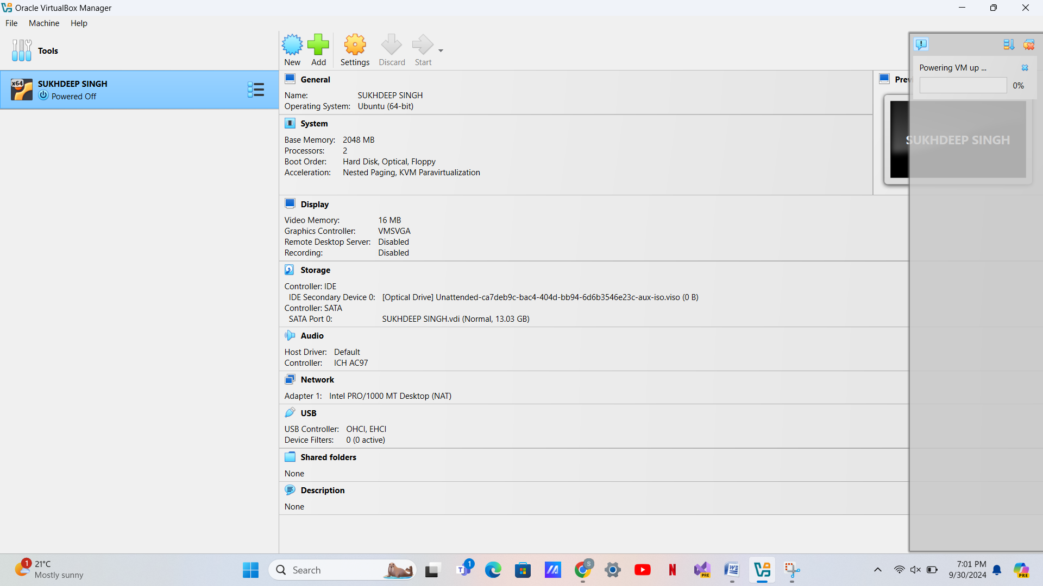

STEP3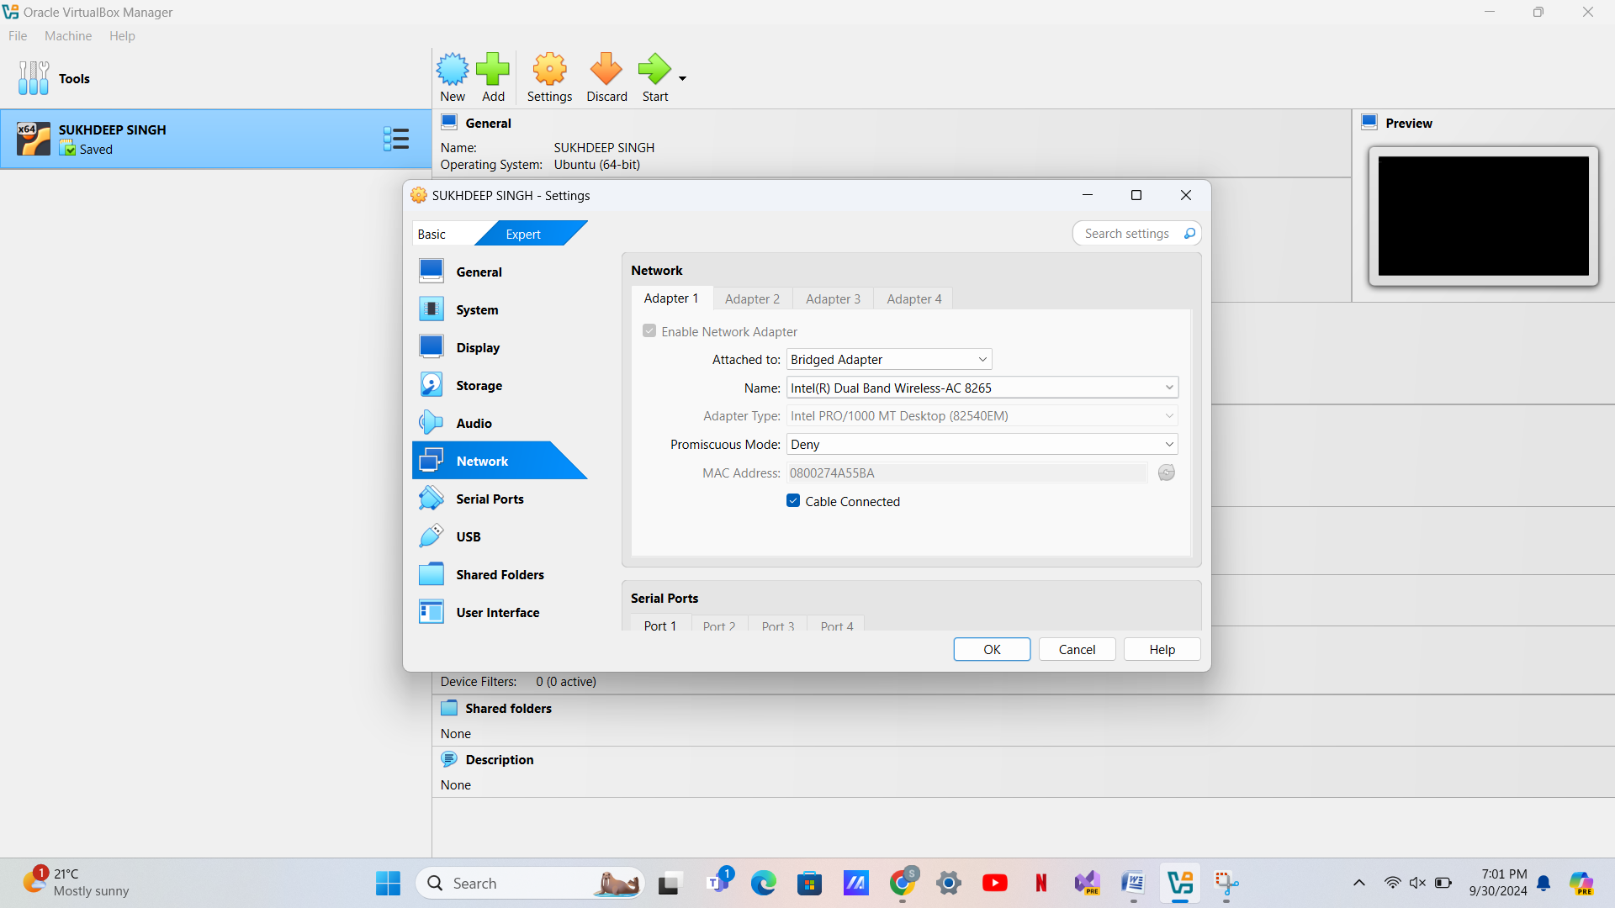

STEP4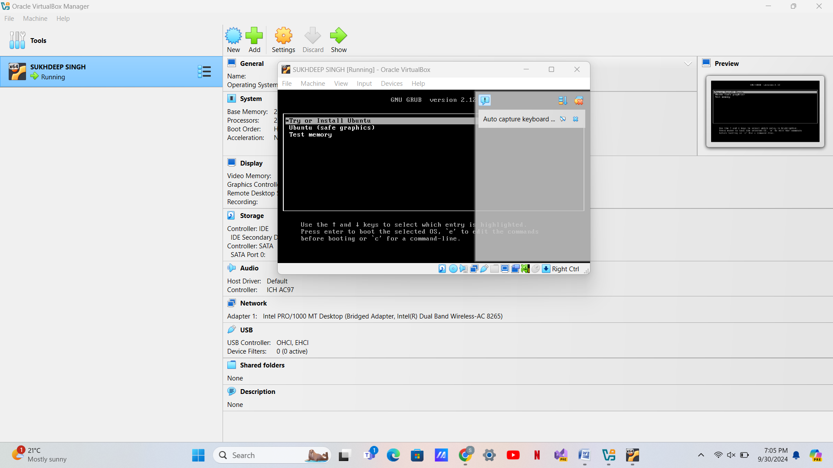

STEP5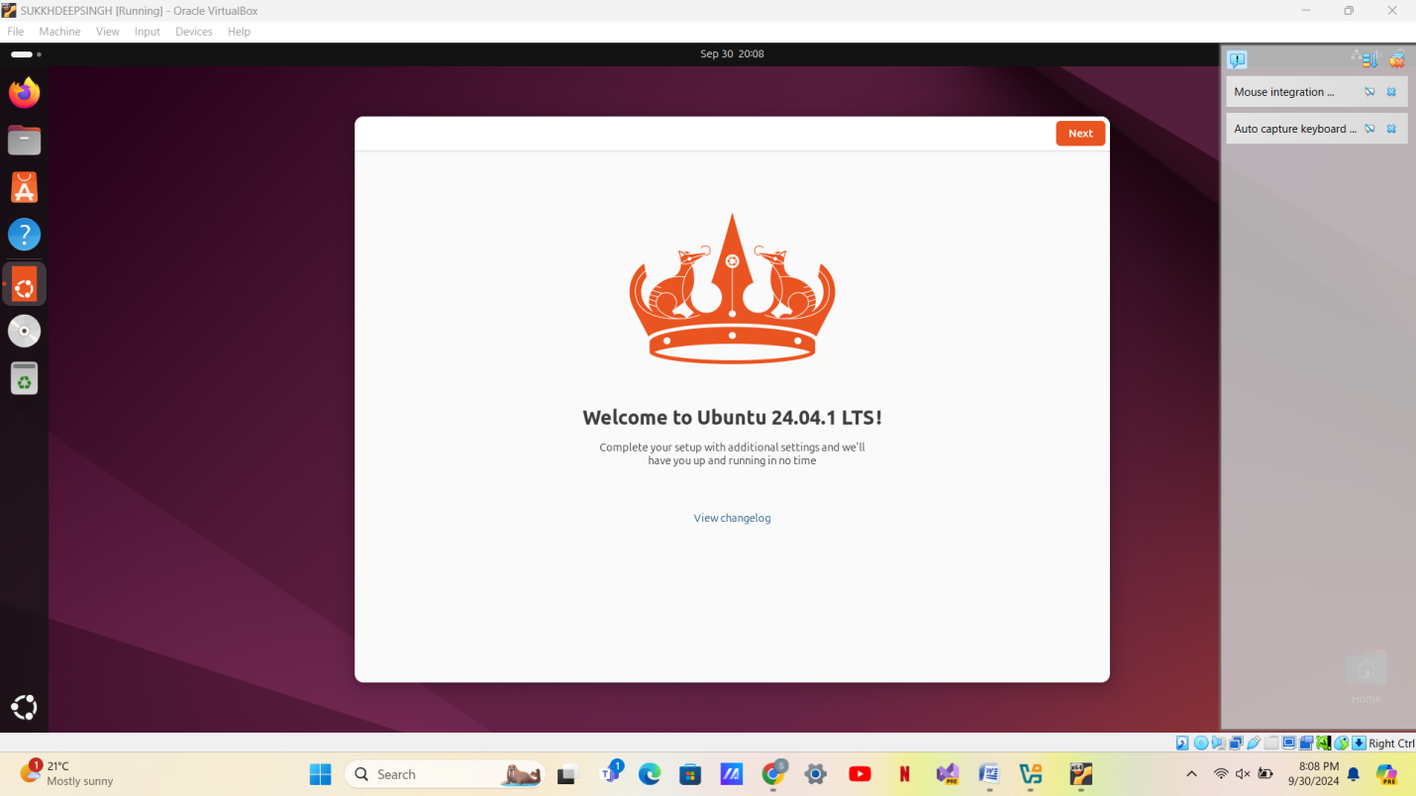

STEP6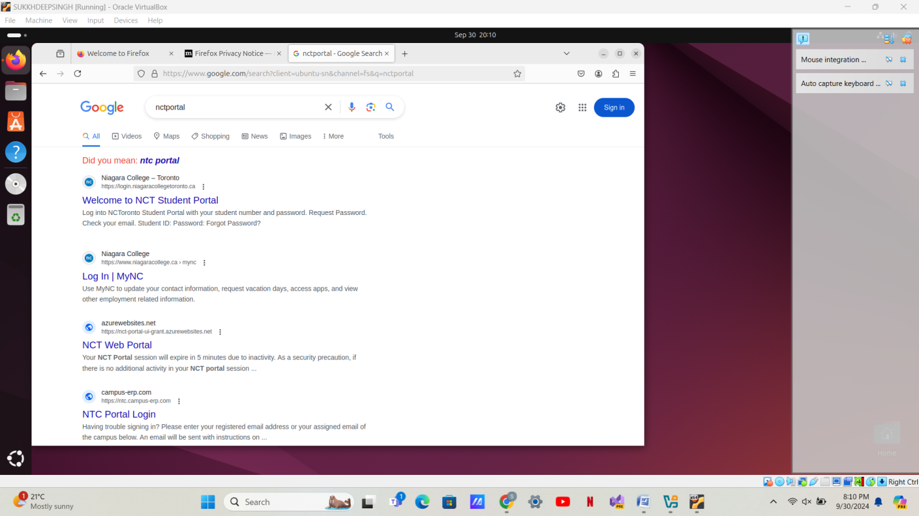

STEP7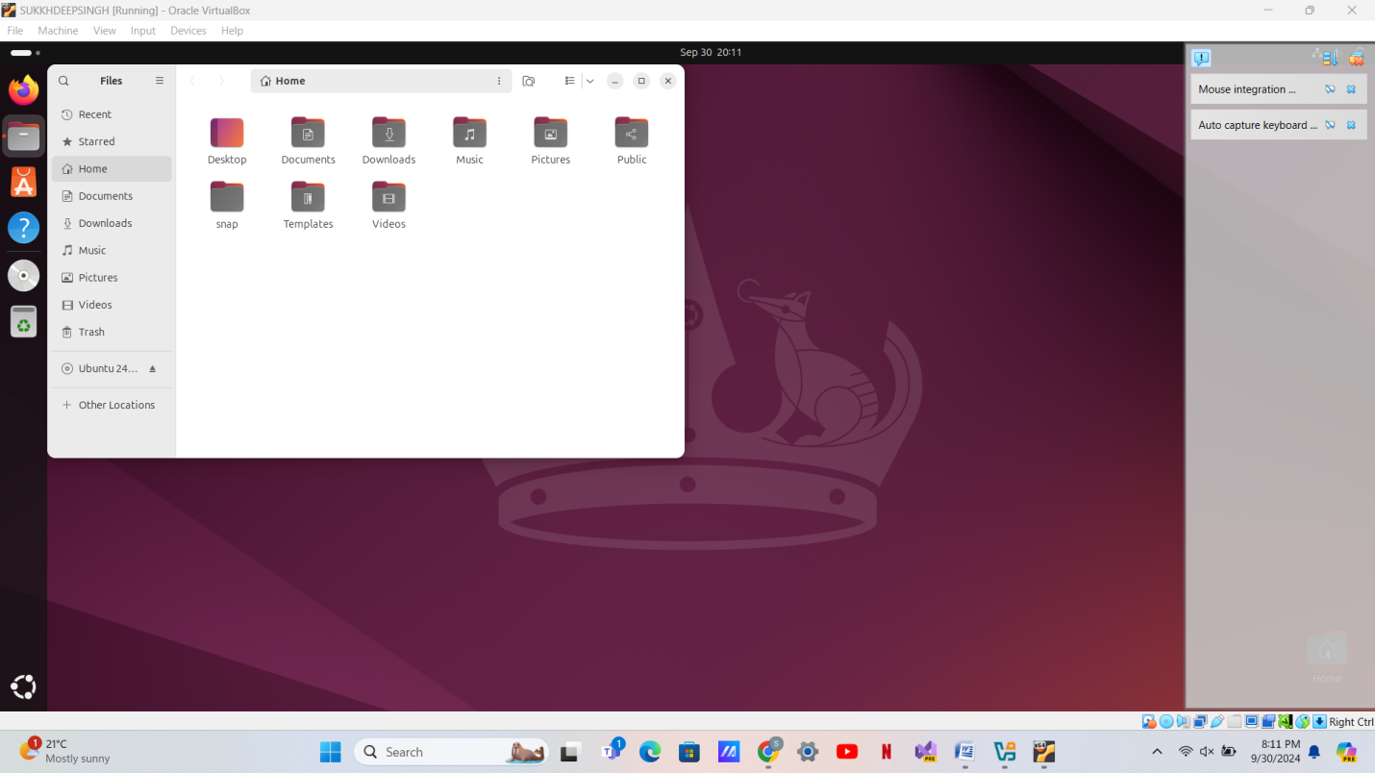

STEP8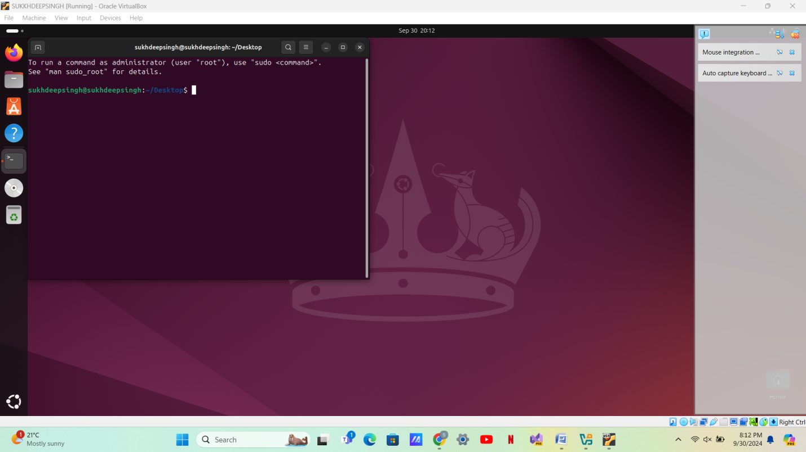

STEP9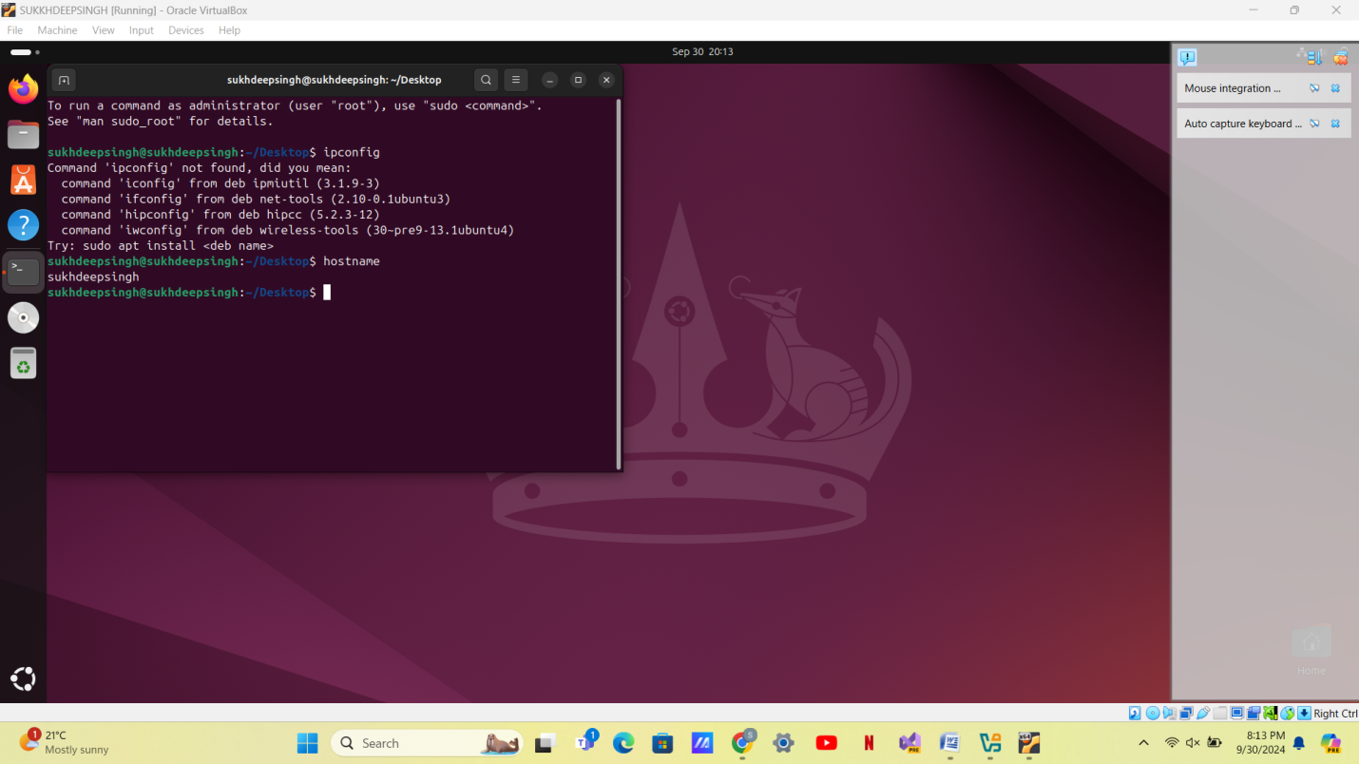

STEP10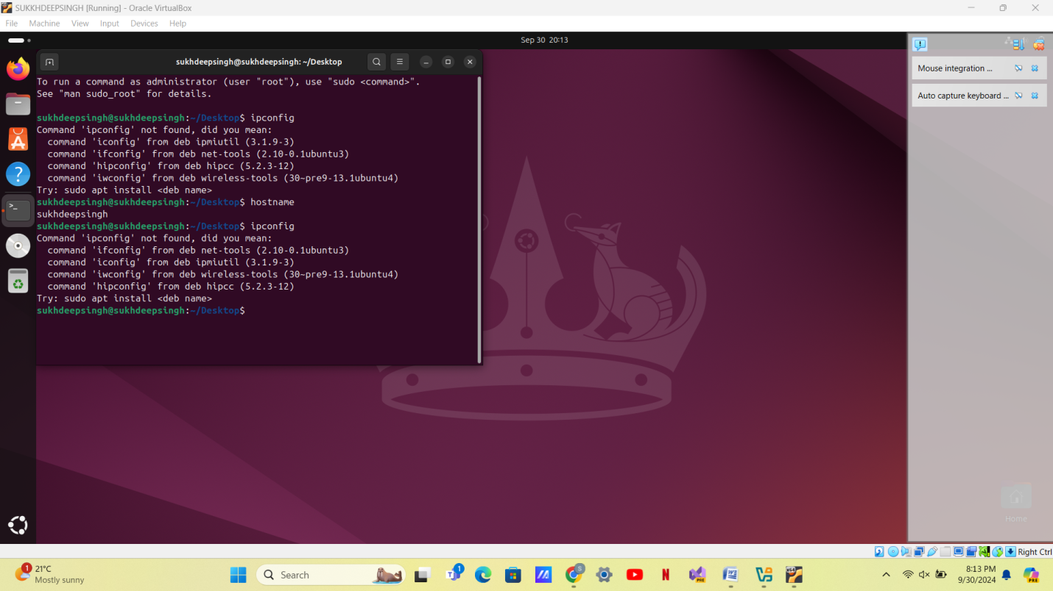

STEP11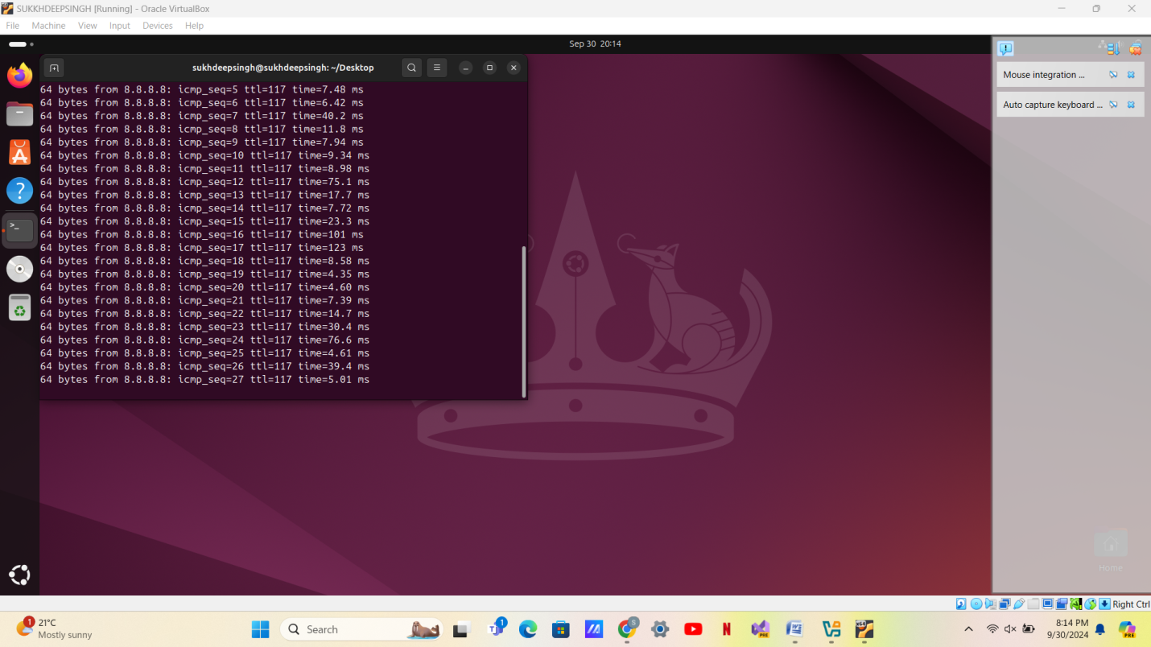

ADVANTAGES: ADD MORE SECURITY LAYER, COST FRIENDLY, CAN WORK ON ONE HARDWARE RATHER THAN MULTIPLE

DISADVANTAGES: COMPLEXITY, IT PUT CPU INTO MORE PRESSURE RESULT IN PROCESSOR HEATING, MAKE PC SLOW TO WORK AND REQUIRE MORE SPACE